The Beer Flavor Wheel
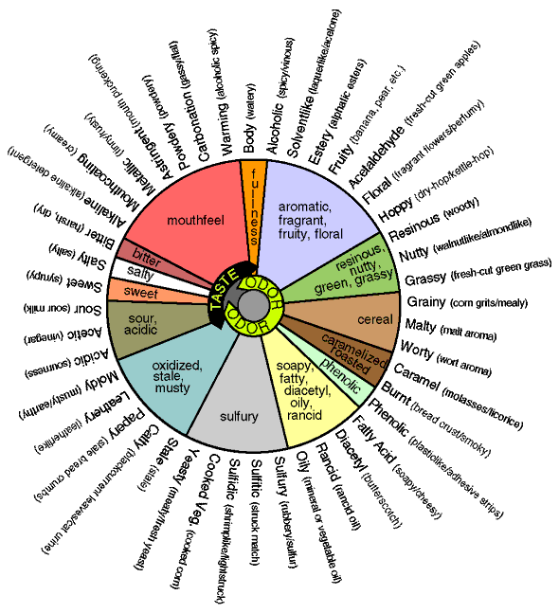
The Beer Flavor Wheel (In Chart Form)
Category | Description (Synonyms) | Odor | Taste | Feel
Aromatic, Fragrant, Fruity, Floral | Alcoholic | * | * | *
Aromatic, Fragrant, Fruity, Floral | Solvent-like (plastic, can-liner, lacquer) | * | *
Aromatic, Fragrant, Fruity, Floral | Estery (banana, apple, fruity) | * | *
Aromatic, Fragrant, Fruity, Floral | Fruity (citrus, berry, melon, . . .) | * | *
Aromatic, Fragrant, Fruity, Floral | Acetaldehyde (fresh cut green apples) | * | *
Aromatic, Fragrant, Fruity, Floral | Floral (roses, geranium, perfume) | * | *
Aromatic, Fragrant, Fruity, Floral | Hoppy | * | *
Resinous, Nutty, Green, Grassy | Resinous (sawdust, resin, cedar, pine, spruce) | * | *
Resinous, Nutty, Green, Grassy | Nutty (sherry-like, walnut, coconut, beans, almond) | * | *
Resinous, Nutty, Green, Grassy | Grassy (fresh-cut grass, straw) | * | *
Cereal | Grainy (raw grain, husk-like, corn grits, flour) | * | *
Cereal | Malty | * | *
Cereal | Worty (fresh-wort aroma) | * | *
Caramelized, Roasted | Caramel (burnt-sugar, toffee, molasses, licorice) | * | *
Caramelized, Roasted | Burnt (burnt bread) | * | * | *
Phenolic | Phenolic (tarry, bakelite, carbolic, pharmaceutical) | * | *
Soapy, Fatty, Diacetyl, Oily, Rancid | Fatty Acid (tallowy, goaty, cheesy, rancid butter) | * | *
Soapy, Fatty, Diacetyl, Oily, Rancid | Diacetyl (buttermilk, butterscotch) | * | *
Soapy, Fatty, Diacetyl, Oily, Rancid | Rancid (rancid oil) | * | *
Soapy, Fatty, Diacetyl, Oily, Rancid | Oily (vegetable oil, gasoline, machine oil) | * | * | *
Sulfury | Sulfury (rotten egg) | *
Sulfury | Sulfitic (burnt-match, choking, burnt rubber) | *
Sulfury | Sulfidic (sewage, natural gas) | *
Sulfury | Cooked Veg. (overcooked greens, cooked corn) | * | *
Sulfury | Yeasty (fresh yeast, meaty) | * | *
Oxidized, Stale, Musty | Stale (old beer) | * | * | *
Oxidized, Stale, Musty | Catty (skunky beer) | * | *
Oxidized, Stale, Musty | Papery (cardboard) | * | *
Oxidized, Stale, Musty | Leathery | * | *
Oxidized, Stale, Musty | Moldy (earthy, musty) | * | *
Sour, Acidic | Acidic (pungent, sharp) | * | *
Sour, Acidic | Acetic (vinegar) | * | *
Sour, Acidic | Sour (lactic, sour milk) | * | *
Sweet | Sweet (syrupy) | * | *
Salty | Salty |  | *
Bitter | Bitter (harsh, dry) |  | * | *
Mouthfeel | Alkaline |  | * | *
Mouthfeel | Mouthcoating (creamy) |  | * | *
Mouthfeel | Metallic (coins, iron, rusty water, tinny) | * | * | *
Mouthfeel | Astringent (mouth-puckering, tannin-like, tart) |  | * | *
Mouthfeel | Powdery (dusty, chalky, particulate) | * | * | *
Mouthfeel | Carbonation (flat/undercarbonated, gassy/overcarbonated) |  | * | *
Mouthfeel | Warming (alcoholic) |  | * | *
Fullness | Body (watery, characterless, satiating, thick) | * | * | *

